

Project Manager
Job Description for©
[Project Name]

Document Control

Document Information
© | Information
Document Id | [Document Management System #]
Document Owner | [Owner Name]
Issue Date | [Date]
Last Saved Date | [Date]
File Name | [Name]

Document History
Version | Issue Date | Changes
[1.0] | [Date] | [Section, Page(s) and Text Revised]

Document Approvals
Role | Name© | Signature | Date
Project Sponsor

Project Review Group

Project Manager©

Quality Manager
(if applicable)

Procurement Manager
(if applicable)

Communications Manager
(if applicable)

Project Office Manager
(if applicable)

Table of Contents

Template Guide 1
1 Overview 2
2 Purpose 2
3 Responsibilities 2
4 Organization 4
5 Relationships 5
6 Skills 5
7 Experience 6
8 Qualifications 6
9 Personality 6
10 Performance Criteria 7
11 Work Environment 7
12 Salary 7
13 Special Conditions 7

Template Guide

What is a Job Description?

A Job Description is a document which outlines a particular role and set of responsibilities on a project. The purpose of a job description is to clarify the scope of work that a particular role is responsible for undertaking and the skills, experience and qualifications necessary to ensure that the role is undertaken effectively. It includes:

- An overview of the respective role
- A list of the specific responsibilities associated with the role
- Clarification of where the role fits within the project organization structure
- A list of the skills, experience and qualifications required
- Measurable performance criteria
- A statement describing the work environment
- The salary package on offer. ©

A Job Description may also be referred to as a “Position Description”.

When do I use a Job Description?

Job Descriptions should be documented whenever it is necessary to formally clarify the roles and responsibilities within a project. Examples of types of project roles which typically require Job Descriptions include:

- Project Sponsor, Project Director, Project Review Group, Project Manager
- Project Quality Manager, Procurement Manager, Communications Manager
- Project Office Manager, Team Leader
- Project Member (Engineer, Developer, Builder, Administrator, Accountant, Planner, Analyst, Designer, Tester). ©
Following the completion of a Job Description, a suitable candidate is appointed to the role and managed according to the performance targets clearly laid out by the Job Description document. Note: It is usual for the Project Sponsor to document the Job Description for the Project Manager and for the Project Manager to document a Job Description for each role reporting directly to him / her.

How to use this template

This document provides a guide on the topics usually included in a Job Description document. Sections may be added, removed or redefined at your leisure to meet your particular business circumstance. Example tables, diagrams and charts have been added (where suitable) to provide further guidance on how to complete each relevant section.

Overview

Summarize the project and role by outlining the:

- Primary objectives and scope of the project
- Background surrounding the formation of this role
- Purpose and key responsibilities of the role
- Reporting relationships within the project
- Primary skills, experience and qualifications required.

Purpose

Describe the purpose of the Project Manager's role within the project. For example:

“The purpose of the Project Manager's role is to undertake the phases, activities and tasks within specified time, cost and quality constraints to deliver the required project outcome and achieve customer satisfaction.” ©

Responsibilities

List the key responsibilities of the role. For instance, the Project Manager is responsible for:

Project Initiation

- Documenting the benefits, costs and available options within a business case
- Undertaking a Feasibility Study to ensure that all options are achievable
- Creating a Terms of Reference which identifies the objectives and scope of the project
- Recruiting suitably skilled and qualified project team members
- Establishing standards and guidelines for the project. ©

Project Planning

- Creating a schedule outlining the sequence of activities and tasks on the project
- Defining all quality targets, standards, assurance and control procedures
- Scheduling labor, equipment and material resources within the project
- Budgeting financial expenditure throughout the project
- Producing a risk management plan to identify and mitigate likely project risks
- Documenting the customer acceptance criteria for each project deliverable
- Establishing a clear communications plan for the project
- Outlining a strategy for the procurement of goods and services.

Project Execution

- Maintaining the project plan to keep those involved informed of progress against the schedule
- Controlling expenditure to ensure delivery within the approved project budget
- Ensuring that adequate quality assurance and control techniques are undertaken to meet the quality targets specified in the Quality Plan
- Managing the approval of all project change requests
- Raising project risks and recommended mitigation plans for approval
- Resolving all project issues currently affecting the project
- Procuring goods and services in accordance with the Procurement Plan
- Managing the configuration of all project deliverables
- Gaining customer acceptance of each deliverable produced by the project
- Undertaking communication processes as specified in the Communications Plan. ©

Project Closure

- Documenting a project closure report and gaining approval from the Project Sponsor
- Undertaking all actions necessary to close the project
- Communicating closure of the project to all project stakeholders.

Organization

Depict the Organizational structure of the project within an Organization Chart. For example:

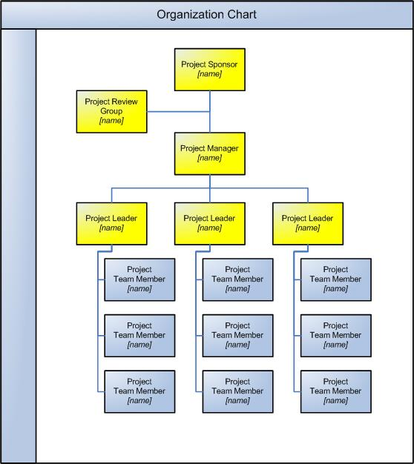

Relationships

Describe the key relationships between the Project Manager and each of the appropriate project stakeholders. For instance:

Project Sponsor
The Project Manager reports directly to the Project Sponsor on a day-to-day basis. As such, the Project Manager will work closely with the Project Sponsor to obtain advice and guidance surrounding the operational delivery of the project.

Project Review Group
The Project Manager must provide the Project Review Group with regular project status information to enable the group to make informed strategic decisions for the project. The Project Manager must communicate all key risks, issues and change requests to the Project Review Group for approval. ©

Project Leaders
The Project Leader reports directly to the Project Manager. The Project Manager must support each Project Leader in undertaking their roles by providing advice, guidance and mentoring necessary for them to achieve their respective project objectives.

Project Team Members
The Project Manager must lead, motivate and inspire the project team to achieve the objectives of the project. This is done by setting clear objectives for each team member and recognizing achievement when each objective has been accomplished.

Skills

Identify the skills and key competencies necessary to undertake the role. For example:

Project Planning
- Ability to produce a detailed project plan, including a Work Breakdown Structure (WBS), dependencies, resources and costs
- Detailed understanding of project planning control techniques.

Resource Management
- Thorough knowledge of resource planning methods
- People management skills, with particular emphasis on performance management.

Financial Management
- Understanding of the financial planning process
- Ability to provide accurate and up-to-date forecasts throughout the project.

Quality Management
- Ability to define appropriate quality targets and standards
- Knowledge of quality assurance and control techniques to ensure that quality targets and standards are met. ©

Change Management
- Awareness of the importance of change management
- Knowledge of effective change management processes and procedures.

Experience

Outline the minimum experience required to undertake this role successfully. Experience may be defined in terms of:

- The types of projects the person has been involved with
- The industries within which the projects were undertaken
- The size and level of complexity of the projects managed
- The number of years spent in managing projects©
- The countries within which the projects were undertaken.

Qualifications

Outline the necessary qualification levels required to undertake this role competently. Types of qualification levels may include:

- High school or college qualification
- University degree or diploma
- Specialist qualification.

Furthermore, identify the particular discipline within which the qualification must apply. For instance:

- Engineering
- Information Technology
- Business Management
- Marketing & Accounting.

Personality

Although it may be difficult, describe the interpersonal characteristics required to ensure that this role is a success. Examples of valuable interpersonal traits for a Project Manager may include being:

- Friendly, open and consultative in nature
- Inspirational, motivational and lively
- Driven by own personal values
- Determined to succeed
- Diplomatic but firm
- Interested in people
- Sociable and outgoing. ©

Performance Criteria

List the Key Performance Indicators which provide a basis upon which to assess the performance of the person in this role. For example:

- Delivery of project outcome within time, cost, quality and scope constraints
- Percentage of achievement of all project objectives
- Percentage of realization of project benefits
- Level of customer satisfaction
- Level of staff satisfaction©
- Number of outstanding issues upon project closure.

Work Environment

Describe the work environment to inform the candidate of the general working conditions associated with this role. Examples include:

- Physical exertion (amount of time standing, sitting, bending or carrying loads)
- Physical environment (working within open-plan or closed, confined space)
- External environment (excessive noise, moving machinery, dust, fumes, gases)
- General environment (level of challenge, organizational change, political pressures).

Salary

Specify the expected salary range and the composition of the salary package, including commissions and benefits. For example:

“The remuneration rate for this role is based on an overall package of $xxx. This comprises:

- An annual salary base of $xxx, paid monthly
- A commission of $xxx, paid on successful completion of the project
- Benefits to the total of $xxx, including allowances for a motor vehicle, gas and mobile phone, paid monthly.” ©

Special Conditions

List any special conditions associated with this role. For instance:
- Identify any special licenses, certificates or credentials required
- Specify any travel involved
- State any after-hours work requirements.

